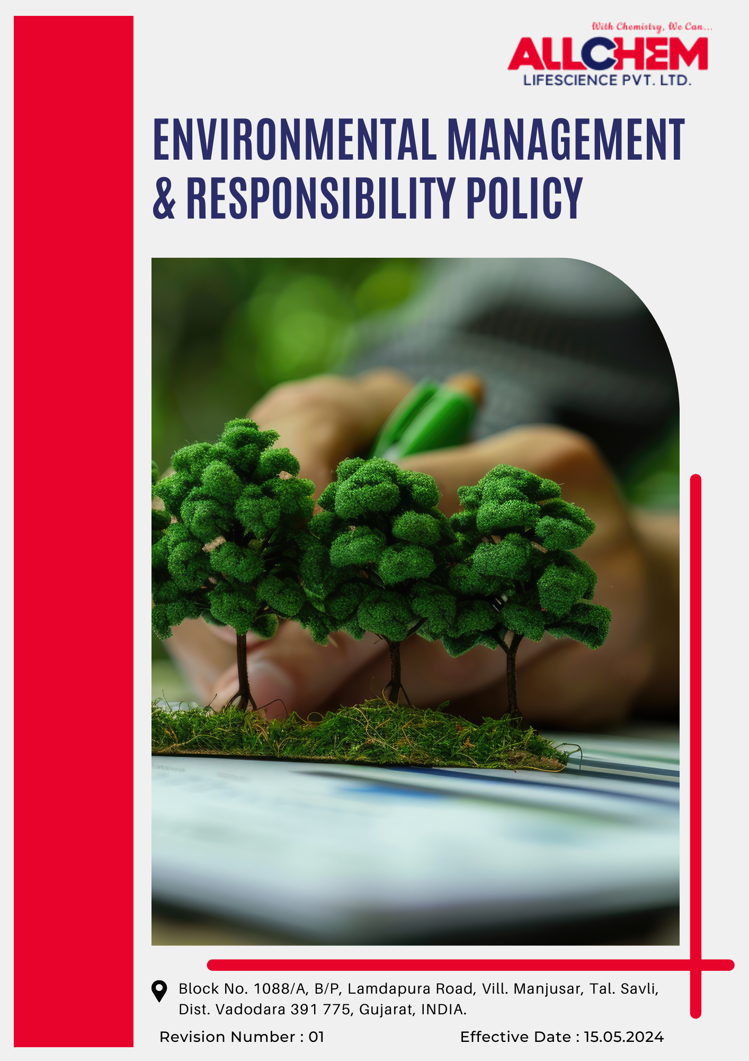
Contents

Preface 3
Scope 3
Policy Declaration 3
Key Action Areas 3
Targets based on our action areas 4
Our Targets in alignment with SDGs 6
Responsibilities 7
Review Mechanism 7
Employee Acknowledgement Form 8

Preface
We at Allchem Lifescience Pvt. Ltd. recognize our responsibility to minimize environmental impacts while maintaining excellence in the manufacturing of pharmaceutical intermediates and specialty chemicals. As a cGMP-compliant organization with ISO 9001:2008, ISO 14000:2004, and OHSAS 18000:2007 certifications, we are committed to integrating sustainable practices across our operations.
Our approach focuses on resource conservation, pollution control, responsible material usage, and regulatory compliance to ensure environmental stewardship in every aspect of our business. We actively seek to enhance energy efficiency, reduce waste generation, and implement cleaner production technologies to mitigate our ecological footprint.
Through continuous improvement, innovation, and collaboration with stakeholders, we aim to uphold the highest standards of environmental responsibility. This policy outlines our commitments, key action areas, and strategies to drive sustainability while ensuring alignment with national and international environmental regulations.
Scope
This policy applies to all aspects of our operations, including manufacturing facilities, research and development activities, supply chains, and corporate offices. It extends to employees, contractors, suppliers, and business partners involved in our processes, ensuring that environmental responsibility is upheld across all levels of our business.
Allchem Lifescience Pvt. Ltd. | Block No. 1088/A, B/P, Lamdapura Road, Vill. Manjusar, Tal.-Savli, Dist.-Vadodara -391 775, Gujarat, India.

Policy Declaration
Allchem Lifescience Pvt. Ltd. embeds environmental responsibility into its operations by reducing its environmental impact, enhancing resource efficiency, and maintaining full compliance with all applicable environmental regulations. With 2022 as the baseline year, we advance sustainability through cutting-edge innovations, eco-efficient manufacturing, and strategic partnerships to fulfill our long-term environmental targets.
Key Action Areas
- Optimize energy-intensive pharmaceutical manufacturing processes and greenhouse gas emissions reductions from production facilities.
- Enhance water efficiency in drug formulation and cleaning processes, maximize water recycling in solvent recovery, and ensure responsible effluent treatment.
- Source raw materials sustainably, mitigate the impact of pharmaceutical waste on aquatic life, support conservation initiatives near operational sites, and minimize land use disruption.
- Reduce airborne emissions from chemical synthesis, control volatile organic compounds (VOCs) and particulate matter, implement advanced scrubber and filtration technologies, and adhere to stringent emission norms.
- Promote green chemistry principles in API intermediate synthesis, strengthen hazardous chemical handling protocols, minimize process waste, and ensure the safe disposal of obsolete or residual intermediates.
- Increase the development of eco-friendly API intermediates with reduced environmental impact by eliminating the use of hazardous reagents where possible, ensuring sustainable packaging, and promoting responsible handling through clear usage guidelines.
- Enhance API intermediates discharge management through process improvements, greener alternatives, and stricter effluent controls.
- Monitor the implementation of take-back programs, ensure safe disposal of expired intermediates, develop sustainable packaging, and support eco-friendly waste treatment.
- Ensure high customer safety and quality standards through transparent labeling, regulatory compliance, and proper handling guidelines.
- Collaborate on sustainable API intermediates manufacturing, promote green chemistry, and raise awareness on responsible disposal.
- Train employees on sustainable practices, promote eco-friendly workplace initiatives, and foster environmental responsibility.

Targets based on our action areas
- Enhancing Energy Efficiency
- Improve energy efficiency in API intermediate manufacturing by integrating sustainable practices, optimizing processes, and implementing energy-efficient technologies.
- Reduce total energy consumption by 20% till year 2028.
- Power 35% of our production facilities with solar energy and enhance automation to optimize energy use by year 2028.

- Reducing GHG Emissions
- Lower scope 3 GHG emissions by 20% through supplier engagement, sustainable raw material sourcing, optimized transportation, and improved waste management practices by 2028.
- Reduce the overall carbon footprint of API intermediate production by promoting sustainability across the supply chain, enhancing logistical efficiencies, and adopting responsible waste management practices.

- Strengthing Water Conservation and Reuse
- Optimize water use in API intermediate synthesis by integrating water-efficient technologies and improving solvent recovery processes.
- Reduce overall water consumption by 20% through conservation measures such as process optimization and water-efficient equipment by year 2028.

- Air Quality Improvements
- To achieve improvements in air quality by using low-emission solvents, advanced filtration, optimized ventilation, and strict regulatory compliance.
- Reduce VOC emissions from API intermediate production by 25% by year 2028 through cleaner solvents and advanced air filtration systems.
- Maintain 100% compliance with national and international air quality standards by implementing continuous emissions monitoring and control technologies.

- Promoting Sustainable Material Use and Waste Management
- Minimize hazardous waste generation by adopting green chemistry principles and optimizing material use in API intermediate synthesis.
- To utilize 30% of materials from recycled or sustainable sources by year 2028.

- Chemical Management
- Ensure 45% of chemicals used in production meet green chemistry principles by year 2028.
- Strengthen chemical risk management by implementing stricter safety protocols, regular monitoring, and employee training on hazardous substance handling.

- Protecting Biodiversity
- Minimize the ecological impact of API intermediate manufacturing by preventing chemical runoff.
- Increase green cover by planting 100 native trees annually and allocating 10% of facility land for eco-friendly landscaping by year 2028.

- Ensuring Customer Health and Safety
- Enhance the safety of API intermediates by eliminating hazardous contaminants and ensuring 100% compliance with international safety standards.
- Conduct comprehensive customer safety risk assessments for all API intermediates to identify and mitigate potential health hazards before commercialization.
- Develop safer and more sustainable formulations for 100% of API intermediates by year 2028, reducing toxic components while maintaining efficacy.
- Sustainable Product use and end-of life management
- Develop clear usage and disposal guidelines for API intermediates to minimize environmental contamination and ensure regulatory compliance.
- Establish a product stewardship program to guide users on responsible API intermediate handling, storage, and disposal.
- Reduce environmental impact by ensuring that at least 40% of packaging materials used for API intermediates are recyclable or biodegradable by year 2028.
- Recover and safely manage 50% of obsolete API intermediates through take-back and recycling initiatives by year 2028.
- Develop formulations that require lower dosages without compromising efficacy, thereby reducing the quantity of chemicals introduced into the environment.
- Driving Environmental Advocacy and Awareness
- Launch an awareness campaign to educate supply chain partners and customers on the environmental impact of API intermediates and encourage sustainable usage.
- Conduct annual sustainability training sessions, aiming for 90% employee participation by year 2028.
- Engage in policy discussions with regulatory bodies to promote stricter environmental standards for API intermediate manufacturing.
Our Targets in alignment with SDGs
- SDG 6: Clean Water and Sanitation- Efforts to optimize water use and reduce consumption by 20% through conservation measures by 2028.
- SDG 7: Affordable and Clean Energy- Initiatives to improve energy efficiency and power 35% of production facilities with solar energy by 2028.
- SDG 12: Responsible Consumption and Production- Strategies to minimize hazardous waste, utilize sustainable materials, and ensure 45% of chemicals meet green chemistry principles by 2028.
- SDG 13: Climate Action- Goals to lower Scope 3 GHG emissions by 20% and reduce the overall carbon footprint of API intermediate production by 2028.
- SDG 15: Life on Land- Commitments to protect biodiversity by planting 100 native trees annually and allocating 10% of facility land for eco-friendly landscaping by 2028.
- SDG 3: Good Health and Well-being- Measures to enhance customer health and safety by ensuring compliance with international safety standards and developing safer formulations for API intermediates by 2028.
- SDG 14: Life Below Water- Advancements in API discharge management to reduce residues in wastewater effluents by 25% by 2028, protecting aquatic ecosystems.
- SDG 17: Partnerships for the Goals- Initiatives to drive environmental advocacy and awareness through campaigns, training sessions, and policy discussions to promote sustainable practices.

Responsibilities
- Environmental Manager: Oversees the implementation and compliance of Allchem's environmental policies, ensuring alignment with regulatory standards and corporate sustainability goals.
- Project Managers and Designers: Integrate sustainability principles into all projects, ensuring that environmental considerations are embedded from the planning phase through execution.
- Employees and Contractors: Adhere to established environmental standards and actively contribute to resource efficiency and sustainable practices in their daily operations.

Review Mechanism
- The Environmental Management Policy will be reviewed once in a two years, or more frequently if deemed necessary by the Environmental Manager, to ensure it remains current with regulatory changes, technological advancements, and industry best practices.
- Regular internal audits and assessments will be conducted to measure performance against environmental targets, with findings reported to senior management for action.
- Feedback from stakeholders, including employees, contractors, regulatory bodies, and the community, will be actively sought and incorporated to enhance environmental initiatives and address any concerns.

Effective Date | : 15.05.2024
Next Review Date | : 15.05.2026
Approved By | :

Employee Acknowledgement Form
I acknowledge that I have received, read, and understood the Environmental Management & Responsibility Policy of Allchem Lifescience Pvt. Ltd. I agree to adhere to the principles outlined in this policy, including responsible resource utilization, waste minimization, energy efficiency, and compliance with environmental regulations.
I recognize my role in supporting the company’s sustainability initiatives and will actively take steps to reduce environmental impact in my daily work. I also accept my responsibility to report any environmental concerns or instances of non-compliance through the designated channels.
By signing this acknowledgment, I confirm my commitment to Allchem Lifescience Pvt. Ltd.’s environmental objectives and to fostering a culture of sustainability within the organization.
Employee Name  Employee ID  Date  Signature | :_______________________________  :_______________________________ :________________________________  : _______________________________

